Fiscal devaluation as a cure for Eurozone ills – Could it work?
Ruud de Mooij Michael Keen
6 April 2012

Troubled Eurozone countries face the difficult challenge of regaining competitiveness without devaluing their currency. Could a fiscal devaluation, shifting taxes from employers to consumers, help? This column presents evidence suggesting that it could, but the devil is in the detail.

Among the traditional necessary conditions for successful membership of a currency union is high labour mobility and/or significant wage and price flexibility to serve as alternative stabilisation mechanisms in the face of a fixed exchange rate. These conditions are absent from many troubled Eurozone countries. Even during the run up to the EMU, however, scholars were suggesting that tax reforms could to some degree substitute for the inability to devalue. Calmfors (1998) in particular pointed out that the effects of a devaluation could be to a large degree replicated by a revenue-neutral shift from social contributions¹ to consumption taxes. In the circumstances of the current Eurozone challenges – large current-account deficit, high unemployment, high social contributions (Table 1) – this strategy, known as a ‘fiscal devaluation’, has been widely advocated.
Table 1. Economic indicators 2011 in selected Eurozone countries
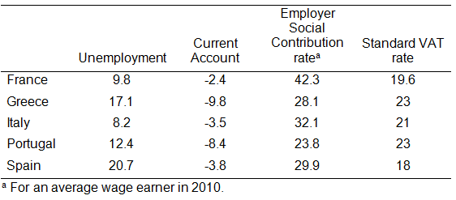
Source: IMF World Economic Outlook database; OECD Tax Database
Earlier columns on this site have proposed fiscal devaluations for Greece (Cavallo and Cottani 2010) and Portugal (Cabral 2011). The idea is that the tax shift in these countries will improve competitiveness and promote exports, so helping them to recover from the deep recession. The basic idea is simply that with nominal wages fixed in the short run, lower labour costs as a result of the cut in social contributions will reduce export prices; the increased VAT, in contrast, will not bear on exports and so will not dampen this effect (indeed since the VAT does apply to imports, which do not benefit from the cut in social contributions, demand should be tilted towards domestic products). In the long run, we would expect wages to adjust, so that the effect ultimately disappears. In the meantime, however, the tax shift should accelerate adjustment toward a new equilibrium and help resolve imbalances.

Does it work?
The theory is neat, but leaves key practical issues unanswered. Not least, how big would such a tax shift need to be to have much of an effect? Macro models have suggested effects that are quite marked, but not spectacular: for instance, simulations of a fiscal devaluation in Portugal equal to 1% of GDP generate a short-term rise in net exports of somewhere between 0.2% and 0.6% of GDP (IMF 2011).
Direct econometric evidence, however, has been lacking – an exception being Franco (2011), who estimates these effects for Portugal and finds them to be potentially larger. In a recent IMF Working Paper (de Mooij and Keen 2012), we use a panel of OECD countries covering 30 years to estimate the effect of various taxes on net exports in an error correction framework that captures both short-term and long-term effects. To capture the implications of the fixed exchange rate regime, these effects are allowed to differ between Eurozone and non-Eurozone observations. The central methodological challenge is to circumvent endogeneity that could bias the results: shocks that lead to increased export demand, for instance, might also increase employment and hence revenue from social contributions. To address this, we use cyclically adjusted revenue data on employer social contributions and the VAT and include their (main) statutory rates as external instruments. This is not a complete answer – for example, policymakers might cut social contributions in anticipation of deteriorating export demand – but the test statistics suggest that the methodological pitfalls are coped with reasonably well.
Our preferred results suggest that a fiscal devaluation switching revenues of around 1% of GDP – which in the Eurozone means, on average, reducing the social contribution rate by 2.6 percentage points and increasing the standard VAT rate by 2.7 percentage points – generates an immediate increase in net exports of between 0.9% and 4% of GDP (Figure 1): rather bigger, that is, than the simulations with macro models suggest. For non-Eurozone observations, the impact is both smaller and less significant. The estimated effect in the Eurozone becomes statistically insignificant in the long run, as the theory predicts. But the long run is rather longer than one might have suspected: the increase in net exports becomes insignificant only after ten years.
Figure 1. Estimated effect of fiscal devaluation of 1% of GDP on net exports in Eurozone (in percent of GDP)
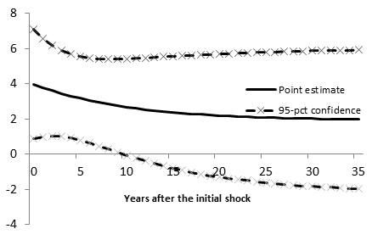
Source: Author calculations based on de Mooij and Keen (2012).

Details, details...
Behind the simple ideas of ‘increase the VAT’ and ‘cut social contributions’, there are many options to consider, and the choices made can powerfully modify the impact of the tax shift.
Focusing the reduction in social contribution rates on the low paid, for instance, would likely reinforce the positive impact on jobs, as employment demand tends to be relatively elastic among low-wage earners – and, for any given loss of revenue from contributions, this allows for a more dramatic shift. The beneficial effects may also be larger if social contributions are reduced in a way that does not break any actuarial link with benefits, since that link – an important part of the social contract in many European countries – may reduce the associated labour market distortions. On the VAT side, where standard rates are already high – as the table above shows them to be in many EU countries, most of which have increased the standard rate since the onset of the crisis and now find themselves close to the informal EU maximum of 25% -- it is likely to be wiser not to strengthen the VAT by increasing that rate further but by raising reduced VAT rates (though the politics of that too, of course, can be difficult).
Distributional effects also need consideration. Concentrating reductions in social contributions (and hence employment gains) on the lowest paid would of course be progressive. And to the extent that the tax switch might have adverse implications for equity – pensioners, for example, lose from the VAT increase but do not directly gain from the contribution cut – accompanying measures may be needed, reducing the space to cut contribution rates. An important current challenge is to identify other ways to finance cuts in social contributions – increased residential property taxes, perhaps – that do not negate the effect and for which the distributional effects are acceptable.
More generally, shifting between taxes in the order of 1% or 2% of GDP, which looks easy on paper, is in practice dauntingly risky, especially when the weakness of the fiscal position is a primary concern.
Despite much talk, in practice few countries have (yet) undertaken fiscal devaluations during the present crisis. While it has been widely discussed in Portugal, it is France that is set to become the first to undertake a textbook fiscal devaluation (known there as a ‘social VAT’): in the second half of 2012, the employer’s social contribution will be cut (for wages up to 2.4 times the minimum wage, at a revenue loss of 0.6% of GDP), with this financed by a 1.6 point increase in the standard VAT rate – approximately 0.5% of GDP – and a higher tax on capital gains (and some modification of benefits to protect poor families with children).
This raises the issue of international coordination. Fiscal devaluation in France both reduces the effectiveness of equivalent steps in its trading partners and worsens the difficulties that fiscal devaluation there would hope to address. This may sound like tax competition of a kind that ultimately leaves all countries worse off as they try to match, say, corporate tax cuts elsewhere. In this case, however, the downside may not be so alarming: there is some evidence that greater reliance on the VAT is associated with stronger long-term growth (Arnold 2008). Major tax shifts of course require courage and persuasive powers from politicians, which should be backed by careful analysis. Our findings suggest, at least, that they can indeed have useful effects on macroeconomic performance.

References
Arnold, J (2008), “Do Tax Structures Affect Aggregate Economic Growth?”, Empirical Evidence from A Panel of OECD Countries”, OECD Working Paper No. 643.
Cabral, R (2011), “The troika should target the trade and the income balance deficits”, VoxEU.org, 15 May.
Calmfors, L (1998), “Macroeconomic policy, wage setting, and employment – what difference does the EMU make?”, Oxford Review of Economic Policy, 14(3): 125-151.
Cavallo, D and J Cottani (2010), “For Greece, a “fiscal devaluation” is a better solution than a “temporary holiday” from the Eurozone”, VoxEU.org, 22 February.
de Mooij, RA and M Keen (2012), “Fiscal Devaluation” and Fiscal Consolidation: The VAT in Troubled Times”, IMF Working Paper no. 12/85. Forthcoming in Alesina and Giavazzi (eds.), Fiscal Policy After the Crisis (National Bureau of Economic Research).
Franco, Francesco (2011), “Adjustment to External Imbalances within the EMU, the Case of Portugal”, mimeo, University of Lisbon.
IMF (2011), Fiscal Monitor (September 2011), appendix 1. “Fiscal Devaluation”: What is it-and does it work?

¹ More precisely, the focus has been on cutting the employer’s contribution, on the grounds that it is the wage before the employee’s contribution and income tax that is most likely to be sticky

Top of Form
Bottom of Form

