Central banks and gold puzzles

Joshua Aizenman Kenta Inoue
19 March 2012

The patterns of gold holding remain a debatable topic at times when the relative price of gold has appreciated while the global economy has experienced recessionary effects. This column studies the curious patterns of gold holding and trading by central banks from 1979 to 2010. It suggests that a central bank’s gold position signals economic might, and gold retains the stature of a ‘safe haven’ asset at times of global turbulence.

On 7 August 2009, the European Central Bank released the following Joint Statement on Gold:
“In the interest of clarifying their intentions with respect to their gold holdings the undersigned institutions make the following statement: Gold remains an important element of global monetary reserves. The gold sales already decided and to be decided by the undersigned institutions will be achieved through a concerted programme of sales over a period of five years, starting on 27 September 2009, immediately after the end of the previous agreement. Annual sales will not exceed 400 tonnes and total sales over this period will not exceed 2,000 tonnes. The signatories recognise the intention of the IMF to sell 403 tonnes of gold and noted that such sales can be accommodated within the above ceilings. This agreement will be reviewed after five years.”

Central bank gold agreements
The ECB statement is another chapter in the curious history of gold positions of major central banks. The patterns of gold holding remain a debatable topic, especially at times when the relative price of gold has appreciated while the global economy has experienced the recessionary effects of the global crisis. While most of the debate deals with the private holding and trading of gold, we focus on the curious patterns of gold holding and trading by central banks. In Aizenman and Inoue (2012) we study two puzzles, ie the passive holding of sizable gold quantities by OECD central banks during most of the last 50 years, and the tendency to report international reserve valuations excluding gold positions. This omission is reasonable for central banks with negligible positions, yet it’s more puzzling for OECD central banks that continue holding, mostly passively, large stocks of gold.

Figure 1 shows the remarkable persistence of gold positions (Billion ounces) for most OECD countries during past years. With the exception of several discrete step adjustments, central banks keep maintaining passive gold stocks, independently of the market price of gold. Another puzzle is the synchronisation of gold sales by central banks, as most reduced their positions in tandem. As the central banks’ adjustment of gold positions may move markets, one may expect central banks to stagger their stock adjustments, yet this has been the exception.

In an era when ‘plastic money’ and ‘electronic money’ gain importance in providing intermediation services, the case of holding, mostly passively, large piles of precious commodity remains an enigma. By revealed preferences, central banks keep viewing gold as a useful part of their portfolio. We compare the patterns of non-gold international reserve to GDP and gold to GDP ratios, applying a prevailing econometric speciﬁcation for explaining international reserves. Both gold and non-gold international reserves have similar sets of determinants, yet these determinants are not stable over time. There is a strong history dependence of gold and non-gold international reserve holdings, and more volatile reserve positions are associated with higher reserves held by central banks.

Figure 2 shows changes of gold holdings (from the previous year in billion ounces) for the US and the rest of 21 countries included in our sample. The figure indicates that gold trading by central banks are synchronised during some specific periods of time, while gold holdings are stable for the other periods; hence, there are likely regime changes of gold holdings. Figure 2 indicates ‘active global gold trading,’ by the shadowed areas, where at least 1/3 of the central banks trade significant gold quantities. Figure 3 reports the average volatility of the log nominal exchange rates per dollar for the 21 sample currencies, excluding the dollar, and the share of countries trading actively significant gold quantities.

Figure 1. Gold holding in billion ounces
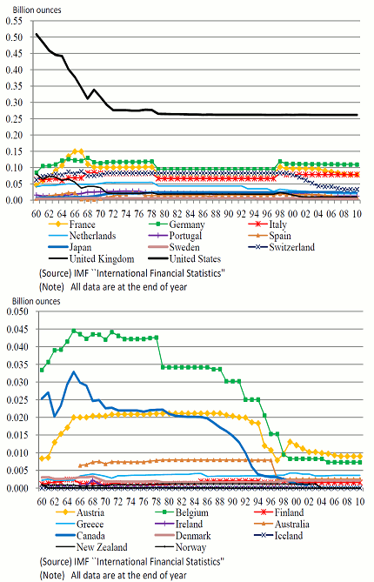

Figure 2. Change of gold holdings in billion ounces under active regime
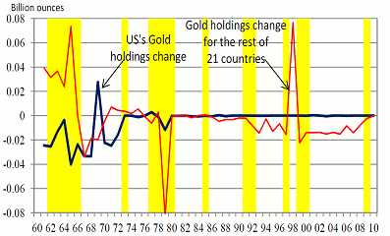
Source: IMF "International Financial Statistics". Note: 1) Shadowed years are under the active trading regime with share of actively gold trading countries out of 22 countries greater than or equal to 1/3. 2) Change of gold holdings is a difference of gold holdings from the previous year.

Figure 3. Share of active gold trading regime and average volatility of nominal exchange rates (NER) per dollar
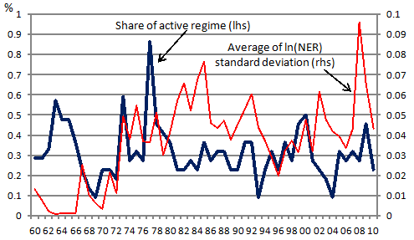
Notes: 1) Share of active trading regime (scaled on the left-hand-side axis: lhs) is the percentage of the countries which had active trading regime out of the 22 sample countries. 2) Active trading regime is identified by rolling regressions with 12-month window for each country: log Gold = a + b logGold(-1). When the null hypothesis that a = 0 and b = 1 is rejected at 5% level, the country is identified as having active gold trading regime at the year. 3) Standard deviation of log Nominal exchange rates (NER) per USP is calculated over the past 12 months, and standard deviations of 21 currencies (excluding USD) are averaged. The average standard deviation is scaled on the right-hand-side axis (rhs). 4) Sample is from 1960 to 2010. Data for Gold holdings by Australia from 1960 to 1965 are missing. 5) NZ and Norway stop holding gold since 1993 and 2004, respectively. We suppose they have stable regimes for these years.

We run a probit estimation to identify the determinants of ‘gold trading regime’. As the exchange rates per dollar become more volatile, central banks are more likely to be under the stable regime. Intriguingly, the sign of log nominal exchange rate changes before and during the recent crisis periods. Before the crisis, as the exchange rate depreciates, central banks were, on average, in the ‘stable gold trading regime’. When the exchange rate depreciated during the crisis, central banks were more likely to trade gold actively. We also find that countries classified as empire are more likely to be under the stable regime during the recent crisis. Our analysis suggests that the intensity of holding gold may be correlated with ‘global power,’ by history of being a past empire, or by the sheer size of a country, and especially by countries that are or were the suppliers of key currency.

Historically, holding large piles of gold indicated global power, as gold and silver were the foundations of the traditional monetary system. The UK, the greatest economic power in Europe during the 18th and 19th centuries, accumulated a massive amount of gold. Under the gold standard, London established its status as the global financial market and acted as the lender of the last resort for gold by the early 20th century (Kennedy 1989, p.245). More recently, under the Bretton Woods system after WWII, the dollar, the only currency pegged to gold, became the key currency for international goods and assets trading. Even after the collapse of the Bretton Woods system, the US remains the dominant economic power and the largest gold holder (Table 1). Consequently, large gold positions of a central bank remain a signal of economic might, possibly recognising that at times of global turbulence, gold has retained the attractiveness of offering a potential hedge (Baur and McDermott 2010).¹

Table 1. Ranking of World official gold holdings (as of Nov or earlier 2011*)
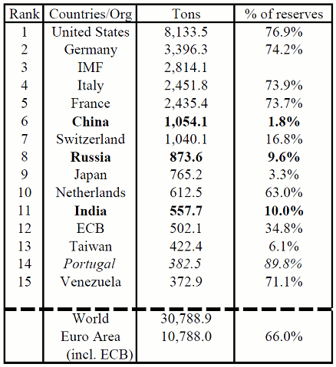
Source: World Gold Council. Note: * Data are taken from the IMF’s IFS, Dec 2011 edition. Holdings are as of November 2011 for most countries and October 2011 or earlier for late reporters.

While we focus on the OECD countries, we include also the two emerging ‘super countries’, China and India, noting that their recent gold holdings increased in tandem with the sharp rise in their economic power (Figure 4). As of November 2011, China is the 6th largest gold holder in the world, Russia is the 8th, and India is the 11th largest. These patterns are consistent with the desire of ‘super emerging markets’ to signal their economic might, to diversify their reserves, and to insure themselves during the global turbulence.

Figure 4. Gold holdings by BRICs
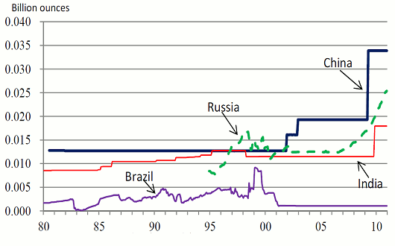
Source: IMF "International Financial Statistics". Note: Data for China, India, and Russia are available since 80/7, 57/1, and 93/12.

The tendency to under-report gold positions in the conventional international reserve statistics remains a managerial issue that deserves explanation. A possible take on it is that most central banks prefer portfolios offering a stable valuation in terms of the chosen basket of global currencies. Central banks refrain from holding stocks, thereby giving up possible gains from diversiﬁcation and a higher expected yield (recall that during most of the past 50 years, stocks outperformed bonds, a situation dubbed ‘the equity premium puzzle’). A possible explanation for central banks’ portfolios is that being a public institution, diversiﬁcation into equities is risky. Central bank managers face the downside risk of being blamed for large declines in a central bank’s portfolio valuation at times of weakening equity markets, while getting very limited gratitude at times of bullish equity markets. These reward patterns encourage ‘loss-aversion’ on behalf of central bank managers, as sizeable equity positions come with the risk of a manager’s job termination during bad times (see Aizenman and Marion 2003 for a further discussion on loss-aversion and central banks).

In these circumstances, the volatility of the price of gold possesses a challenge for international reserves managers. Not reporting the market value of gold as part of the international reserve position may be a working solution for a central bank wishing to maintain a sizeable gold position, while minimising the criticism that may occur at times when the price of gold declines. Similar incentives apply when the central bank is concerned that capital gains associated with gold appreciation may be taxed by the ﬁscal authority, whereas capital losses associated with gold depreciation would be viewed as reﬂecting portfolio mismanagement. In either case, the central bank is exposed.
To conclude, gold retains its unique stature of a ‘safe haven’ asset at times of global turbulence, where large central banks’ gold position signals economic might.

References
Aizenman, Joshua and Marion, Nancy (2003), “The high demand for international reserves in the Far East: What is going on?,” Journal of the Japanese and International Economies 17(3): 370–400.
Aizenman, Joshua and Kenta Inoue (2012), “Central banks and gold puzzles,” NBER Working paper 17894.
Baur, Dirk and McDermott, Thomas (2010), “Is gold a safe haven? International evidence,” Journal of Banking and Finance 34(8): 1886–98.
ECB (2009), “Joint Statement on Gold”, press release, 7 August.
Kennedy, Paul (1989), The Rise and Fall of the Great Powers, Vintage.

¹ Looking at the patterns during 1979 to 2009, they found that gold is both a hedge and a safe haven for major European stock markets and the US but not for Australia, Canada, Japan and large emerging markets such as the BRIC countries. Gold was a strong safe haven for most developed markets during the peak of the recent ﬁnancial crisis.

Top of Form
Bottom of Form

