A tale of two depressions redux

Barry Eichengreen Kevin H O’Rourke
6 March 2012

The debate over stimulus versus austerity continues unabated. This column shows that, while industrial production and trade recovered much more quickly than during the Great Depression, both series now appear to be slowing down. It suggests that, as St Augustine would have said had he been managing director of the IMF, there is a case for additional fiscal consolidation and monetary normalisation, but not yet.

The debate over stimulus versus austerity continues unabated (eg Corsetti and Muller 2012). Eighty percent of economists surveyed by the Booth School of Business at the University of Chicago agree that the stimulus bill passed by the US Congress in 2009 successfully lowered the rate of unemployment. But this also means that 20% are either sceptical or uncertain – and that doesn’t even count a number of high-profile conservative members of the profession who did not participate in the survey.

For those who are convinced that the stimulus worked, moreover, there is the troubling fact that, reflecting worries about debt sustainability, it is now being withdrawn. This threatens to create headwinds for growth long before levels of unemployment have returned to normal.

In Europe, where worries about fiscal sustainability are even more intense, the idea that budgetary consolidation can be expansionary has clearly lost traction, although this has not yet led to a serious rethink, much less action, on the part of policymakers.

Central banks for their part have taken a number of extraordinary steps to sustain the recovery, most recently Operation Twist in the US, the ECB’s Long-Term Refinancing Operations 1 and 2, and the Bank of Japan’s renewed commitment to quantitative easing. But those same policies are criticised for pushing up commodity prices, for pushing up emerging-market currencies and inflation, and for pushing up risk-taking by international banks. All of this creates pressure for central banks to abandon their unconventional policies and begin to normalise the level of interest rates sooner rather than later.

Policy is about tradeoffs
Budgetary consolidation and monetary normalisation address concerns with fiscal sustainability and moral hazard but at the same time darken the growth picture in the short run. Whether policymakers should go down this road, and if so how far, should depend on the state of the economy.

From the outset of the crisis we have argued that this debate needs to be informed by data on economic performance, and that it is important to consider not just individual national economies in isolation but global trends. The crisis and now the recoveries, such as they are, were and are global. Economies are interdependent. Policies have international spillovers.

How are we doing? Today versus the Great Depression
Figure 1 updates our earlier comparison of global industrial production following its April 2008 peak with global industrial production during the Great Depression (Eichengreen and O’Rourke 2010). The striking divergence of the two series a year into the two crises is well known, but the striking new development is how the growth of global industrial output now appears to be slowing. The uptick in the most recent month for which data are available (December 2011) is promising, but this follows a series of months when the series remained essentially stagnant. And while December saw substantial growth in a small handful of countries, notably Japan and emerging Asia, elsewhere, notably in the Eurozone, industrial production declined.

Turning to global trade (Figure 2), the picture is equally mixed. What is well known is that while global trade fell even faster in the recent crisis than during the Great Depression, it also recovered more quickly. But trade is now also fluctuating without direction, at levels barely higher than those of April 2008.

Figure 1. World industrial production, now vs then
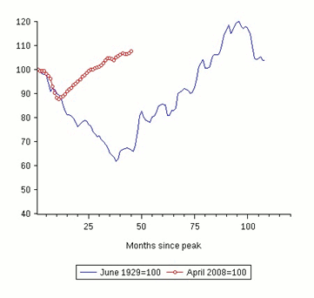
Figure 2. Volume of world trade, now vs then
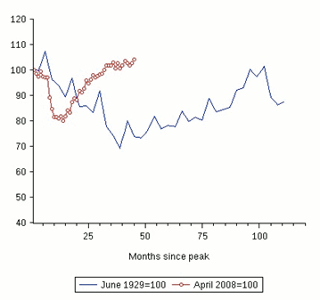

And while there is much commentary to the effect that accommodating central-bank policies have fuelled an equity-market boom, especially in the US, it is worth observing that world equity markets remain considerably below pre-crisis levels (Figure 3).

Policy implications
All this suggests to us that further curtailing policy support now would – to return to the language of tradeoffs – have more costs than benefits.

As St Augustine would have said had he been managing director of the IMF, there is a case for additional fiscal consolidation and monetary normalisation, but not yet.

Figure 3. World equity markets, now vs then
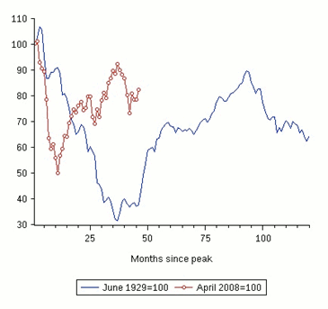

References
Corsetti, G and G Muller (2012), “Has austerity gone too far?”, VoxEU.org, 20 February.

Eichengreen, B and K O’Rourke (2010), A tale of two depressions: What do the new data tell us? February 2010 update, VoxEU.org, 8 March.

Top of Form
Bottom of Form

