Shifting motives: Explaining the build-up in official reserves in emerging markets since the 1980s

Atish R Ghosh Jonathan D Ostry Charalambos Tsangarides
6 February 2012

Over the past three decades, emerging market economies have been rapidly accumulating reserves – a trend that has resumed, and even accelerated, following the 2008 global financial crisis. This column examines factors driving this accumulation and how these factors have evolved over time and differed across countries.

Over the past few decades, despite greater exchange-rate flexibility, emerging economies have been accumulating large stocks of international reserves. Reserve holdings, which averaged about 5% of GDP in the 1980s, have been doubling every decade since, reaching some 25% of GDP by 2010. The dispersion in reserve holdings across these economies has also risen, with the difference between the top and bottom quartiles widening from 3% of GDP in 1990 to 13% of GDP by 2010 (Figure 1); as such, there is considerable time series and cross-sectional variation in reserve holdings. This has raised concerns that emerging economies are uselessly stockpiling reserves, that they are deliberately maintaining undervalued exchange rates, and even that they are imperilling the stability of the international monetary system (see Dadush and Stancil 2011, Portes 2010, and Ghosh et al 2010). Much of the policy debate naturally hinges on why these countries are accumulating reserves – whether it is precautionary demand in an uncertain world, a by-product of mercantilist growth strategies, or some other motive.

Figure 1. International reserves held by emerging markets 1980–2010 (in percent of GDP)
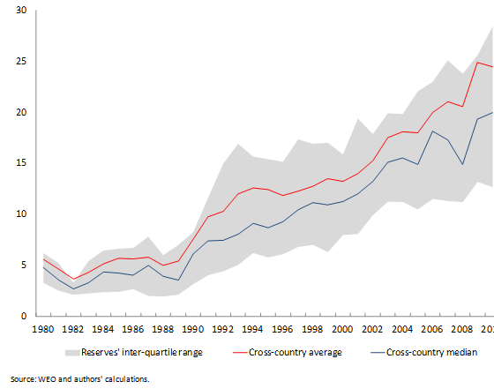
Sources: WEO and authors’ calculations.

In a recent paper (Ghosh et al 2012), we take a fresh look at what has been driving reserve accumulation over the period 1980–2010. We consider both precautionary (country insurance) and non-precautionary (mercantilist) motives, and examine how these vary over time and across the distribution of reserve holders. Reserves held for precautionary purposes are intended to buffer absorption against current or capital-account shocks, lessening both the likelihood and impact of a sudden stop in capital inflows or a sharp rise in outflows. Empirically, several studies, including de Beaufort Wijnholds and Kapteyn (2001), Cheung and Qian (2009), Bastourre et al (2010), Obstfeld et al (2010), and others document the importance of precautionary motives.

A quite different explanation is modern mercantilism – reserves accumulation as a by-product of export-led growth strategies that rely on sterilised intervention to maintain an undervalued currency (see Dooley et al 2003 and Ghosh and Kim 2009). Despite the theoretical plausibility, the empirical literature to date (notably Aizenman and Lee 2007 and Delatte and Fouquau 2010) has had little success in establishing this link robustly in the data.

While precautionary and mercantilist motives may both be reasonable explanations for the trends in reserves, it is possible that the relative importance of these determinants has shifted over time. In a similar vein, different motives might apply at different points along the sample distribution of reserve holdings – for instance, countries that hold low levels of reserves may do so because they are not very financially integrated and are mostly concerned about current-account rather than capital-account shocks. Accordingly, there is no reason to believe that the effect of various explanatory variables will be the same across the distribution of reserve holdings. To test this hypothesis our analysis incorporates three elements: a nested model in which, in addition to the exchange-rate regime, insurance against current- and capital-account shocks, as well as mercantilism can all play a role; two new proxies for possible mercantilism/currency undervaluation (including based on the methodologies used by the IMF in its own exchange-rate assessments); and the use of quantile regressions, which allow the effects of the explanatory variables to vary systematically along the reserves distribution.

Average reserve holdings and sub-periods pre- and post-Asian crisis
We find that precautionary and mercantilist motives together can explain a large proportion of the average sample variation. The full model, including exchange-rate regime, current- and capital-account precautionary variables, and mercantilist motives explains about 56% of the variation in reserve holdings without the inclusion of annual or country fixed effects. Moreover, most coefficient estimates are of the expected sign and are statistically significant, with the notable exceptions of the exchange-rate regime variables, short-term debt, and the implied carry cost of reserves, all of which are statistically insignificant (Figure 2).

Figure 2. What drives average reserve accumulation?
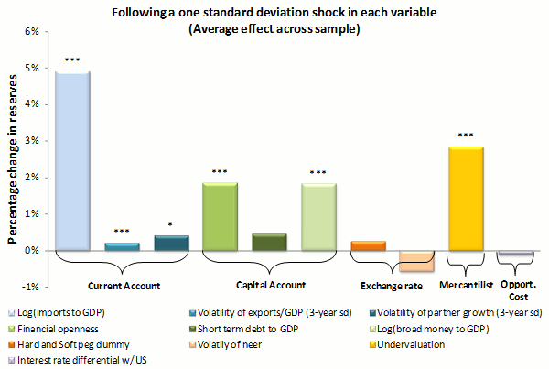
Source: Authors’ calculations.

How have the motives for holding reserves evolved over time? Regressions over the sub-periods suggest shifting motives for holding reserves, in line with our hypothesis (Figure 3). In the 1980s and 1990s, emerging countries held reserves to defend their exchange-rate pegs or as a buffer against current-account shocks. Following the Asian and other emerging economies’ capital-account crises, however, insurance against capital-account shocks (including banking crises that could spill on to the balance of payments) gained importance. At the same time, mercantilism in the form of an undervalued real exchange rate appears to have contributed to higher reserve holdings. While this pattern accords well with intuition, it need not be limited to motives shifting over time: different levels of reserves across countries at a given point in time may likewise correspond to different reasons for holding them.

Figure 3. Reserve accumulation across periods
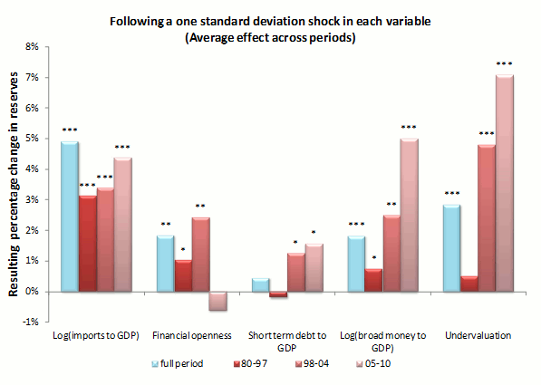
Source: Authors’ calculations.

Low vs high reserve holders
Do countries that hold a lot of reserves (in relation to GDP) have different motives for holding reserves than those countries with few reserves? We find important differences in the determinants of reserve holdings at various points in the distribution (Figure 4). Overall, insurance motives for countries that hold low levels of reserves (in relation to GDP) centre mainly on current-account shocks, whereas those for higher reserve holders (again in relation to GDP) tend to centre more on capital-account shocks such as banking system liabilities. The carry cost of reserves, which is proportional to the amount of reserves held, is only pertinent for countries with relatively high reserves-to-GDP ratios. Currency undervaluation seems to be relevant across the reserves’ distribution, though we suspect that for some low-reserves holders this may be more a reflection of currency crises and collapsed real exchange rates than of deliberate mercantilism.

From the early 1990s onwards, reserve holdings by emerging economies started increasing, eventually at a faster pace than the model would predict. Insurance against capital-account shocks is the most important determinant of the rise in predicted reserves, especially in the years following the Asian financial crisis. Undervaluation of the exchange rate becomes progressively important in the latter half of the 2000s, and since this is in the context of increasing reserves, it probably represents intentional undervaluation. Insurance against potential current-account shocks remains a positive, but marginal, contributor to reserves accumulation. Finally, the average residual is positive starting around 2000, except in 2008 when the economies ran down reserves as their currencies came under pressure from both the current-account shock (the fall in export demand) and the capital-account shock (the sudden stop of capital inflows).

Figure 4. Reserve accumulation across quantiles of the reserve distribution
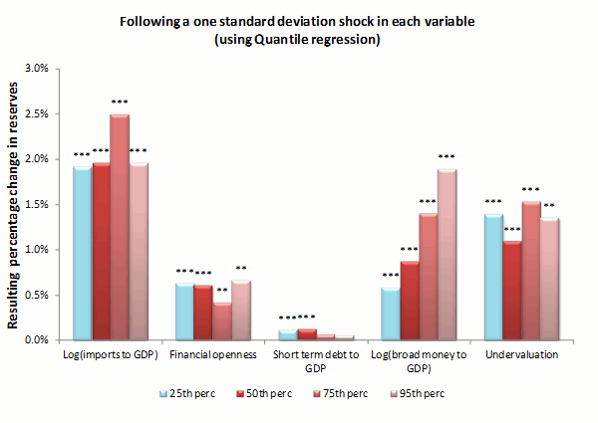
Source: Authors’ calculations.

Figure 5. Actual and fitted cumulative change in reserves
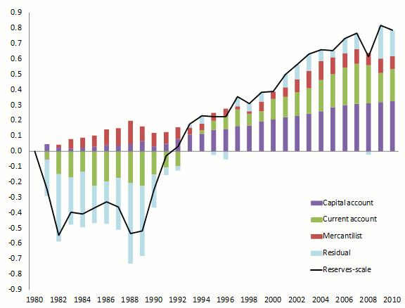
Notes: Actual and quantile regression fitted change in log (reserves/GDP) excluding effects of scale variables (populations and per capita income) and exchange-rate regime variables.
Source: Authors’ calculations.

Accounting for emerging-market economy reserve holdings
How well does our model account for emerging-market economy reserves? Figure 5 graphs the cumulative change in reserves (in % of GDP, averaged across countries) as well as the fitted values for the quantile regression (excluding the effects of the scale variables). The residuals are large and negative following the onset of the 1982 debt crisis until the start of the 1990s – suggesting that emerging market economies involuntarily held fewer reserves than they would consider sufficient for precautionary purposes. During this period, undervaluation contributes positively to the predicted increase in reserves while precautionary demand against current-account shocks contributes negatively because these shocks are becoming less important during this period. Insurance against capital-account shocks contributes positively, albeit minutely, to accumulation in the early part of the sample.

Conclusions and policy implications
Over the past three decades, emerging economies have been stockpiling international reserves. We argue that accounting for this accumulation in reserves requires several explanations: precautionary demand against both current- and capital-account shocks as well as intentional or unintentional undervaluation of the exchange rate. No single explanation can account for the behaviour of all countries at all times.

We find that insurance against current-account shocks was relatively more important in the early part of the sample, and for countries that hold low reserves more generally. Undervaluation of the exchange rate is also important for low reserve holders, but to the extent that it represents collapsed real exchange rates in the aftermath of debt or currency crises, it need not be indicative of deliberate mercantilism.

Following the emerging-market capital-account crises of the 1990s, especially after the Asian crises of 1997–98, insurance against capital-account shocks became increasingly important. Moreover, the export booms that followed the real exchange rate collapses in these crises likely demonstrated the benefits of undervalued currencies for export-led growth. Starting in the early 2000s, currency undervaluation again becomes an important determinant of reserve accumulation – though this time in the context of rising reserves, and hence more probably due to deliberate undervaluation through sterilised intervention. Even including all three motives for holding reserves, and allowing different motives to apply at different points in the reserves distribution, there remains a positive residual for the more recent years (except when the economies ran down reserves in the global financial crisis). Either emerging economies are becoming more risk averse – or they have learned that the potential shocks are even larger than past experience had led them to believe.

References
Aizenman, Joshua, and Jaewoo Lee (2007), “International Reserves: Precautionary Versus Mercantilist Views, Theory and Evidence”, Open Economies Review, 18:191-214.
Bar-Ilan, Avner, and Nancy P Marion (2009), “A Macroeconomic Perspective on Reserve Accumulation”, Review of International Economics, 17:802-823.
Bastourre, Diego, Jorge Carrera, and Javier Ibarlucia (2009), “What is Driving Reserves Accumulation”, Review of International Economics, 17:861-877.
Ben-Bassat, Avraham, and Daniel Gottlieb (1992), “Optimal International Reserves and Sovereign Risk”, Journal of International Economics, 33:345-362.
Cheung Yin-Wong, and Xingwang Qian (2009), “Hoarding of International Reserves: Mrs. Machlup’s Wardrobe and the Joneses”, Review of International Economics, 17: 824-843.
De Beaufort Wijnholds, J Onno, and Arend Kapteyn (2001), “Reserve Adequacy in Emerging Market Economies”, IMF Working Paper 01/143.
Dadush, Uri and Bennett Stancil (2011), “Why are reserves so big?”, VoxEU.org, 9 May.
Delatte, Anne-Laure, and Julien Fouquau (2011), “What Drove the Massive Hoarding of International Reserves in Emerging Countries? A Time-Varying Approach”, Review of International Economics, forthcoming.
Dooley, Michael P, David Folkerts-Landau, and Peter Garber (2003), “An Essay on the Revived Bretton Woods System”, NBER Working Paper No. 9971, National Bureau of Economic Research.
Durdu, Ceyhun Bora, Enrique G Mendoza, and Marco E Terrones (2009), “Precautionary Demand for Foreign Assets in Sudden Stop Economies: An Assessment of the New Mercantilism”, Journal of Development Economics, 89:194-209.
Ghosh, Atish R, Jonathan D Ostry, and Charalambos Tsangarides (2010), “Exchange Rate Regimes and the Stability of the International Monetary System”, IMF Occasional Paper No. 270, International Monetary Fund.
Ghosh, Atish R, Jonathan D Ostry, and Charalambos Tsangarides (2012), “Shifting Motives: Explaining the Buildup in Official Reserves in Emerging Markets since the 1980s”, IMF Working Paper No. 12/34, International Monetary Fund.
Ghosh, Atish R, Kim (2009), “Pegged Exchange Rates, Export Subsidies, and Consumption Taxes – Some Equivalence Results of Relevance to Bretton Woods II” (mimeo)
Obstfeld Maurice, Jay Shambaugh, and Alan M. Taylor (2010), “Financial Stability, the Trilemma, and International Reserves”, American Economic Journal: Macroeconomics, Vol. 2, pp. 57–94.

Portes, Richard (2010), “Currency wars and the emerging-market countries”, VoxEU.org, 4 November.

Top of Form
Bottom of Form

