Understanding past and future financial crises

Pierre-Olivier Gourinchas Maurice Obstfeld
1 February 2012

What explains the different effects of the crisis around the world? This column compares the 2007–09 crisis to earlier episodes of banking, currency, and sovereign debt distress and identifies domestic-credit booms and real currency appreciation as the most significant predictors of future crises, in both advanced and emerging economies. It argues these results could help policymakers determine the need for corrective action before crises hit.

The global financial crisis of 2007–09 brought with it the most severe global slowdown since the early 1980s (O’Rourke and Eichengreen 2010). In contrast to that earlier episode, however, the negative output effects were relatively more severe in advanced economies compared to most developing regions, and the bounce back has generally been more vigorous in the developing world.
As Figure 1 shows:
- Even by 2010 output levels in the Eurozone, Japan, UK, and US remained barely above, or even below, their 2006 levels.
- Severe aftershocks from the 2007 financial earthquake – in the form of the Eurozone’s sovereign debt crisis and banking woes – continue unabated.¹
Figure 1. Real GDP relative to 2006 levels
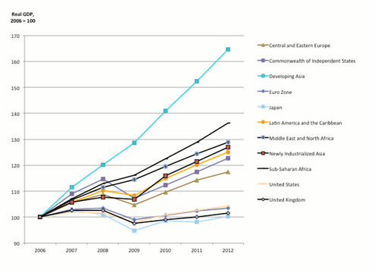
Source: IMF, September 2011 WEO database; forecasts for 2011, 2012

What explains the seemingly different effects of the crisis in different parts of the world? Answers to that question can be especially useful in predicting future crises.

In recent research (Gourinchas and Obstfeld 2012), we have tried to understand the divergent behaviour of mature and emerging economies by comparing the 2007–09 crisis to earlier episodes of banking, currency, and sovereign debt distress throughout the world. Drawing on earlier chronologies, and adding a bit of our own judgement and primary research, we develop a database of the various types of financial crisis events that occurred between 1973 and the early 2000s.² We then rely on an event-study methodology to inspect the antecedents and aftermaths of crises, focusing our analysis on a limited set of variables that earlier researchers have identified as important empirical or theoretical indicators of impending financial stress.

Our primary goal is to see if there are commonalities in the prologues to past crises as between advanced and emerging countries, and if the relative fortunes of different global regions differed in the recent recession because of significantly different policy choices or financial-market developments. In turn, such information could aid in predicting future crises.

What are the ‘smoking guns’?
Our event-study analysis points to:
- Escalating leverage as one of the key ‘smoking guns’ in the run-up to both banking and currency crises.
- Real exchange rates tend also to be strong, relative to tranquil periods, before all types of crisis.
The build-up of domestic credit prior to the 2007–09 crisis was much more pronounced for advanced than for emerging economies. Within the latter set of countries, the main build-up of leverage occurred in Central and Eastern Europe, which, not coincidentally, also suffered some of the most severe negative effects on output.³

Our results are consistent with a string of earlier contributions stressing the perils of rapid domestic-credit growth, as well as with warnings issued by researchers at the Bank for International Settlements since the early 2000s.⁴

While our event-study analysis suggests that occurrences such as domestic-credit booms tend to precede crises on average, it does not allow us to determine whether those occurrences are likely to take place also without triggering a crisis – issuing false positive signals, like Paul Samuelson’s celebrated stock market.

To explore that problem, we follow a well-developed ‘early warning’ literature and estimate an econometric model of the probability of different varieties of crisis given a set of potential vulnerability indicators such as domestic-credit booms, the current-account deficit, international reserves, real currency appreciation, and a measure of the output gap.
The estimated model implies that:
- Domestic-credit booms and real currency appreciation are the most robust and significant predictors of future crises, in both advanced and emerging economies.⁵
- For the latter group of countries, higher international reserves are also associated with a lower probability of subsequent crises.
- Finally, we find that public debt plays a role in the case of banking crises.

Would this knowledge have helped today’s crisis managers?
As a test of the policy relevance of these results, one can ask if a policymaker armed with our empirical probability model and available data would have inferred that the industrial economies were entering a period of likely crises during the latter 2000s.
Figure 2 uses our empirical approach to construct three-year-ahead out-of-sample forecasts of the probability of systemic banking crises from 1991 to 2009 for advanced economies. As it happens, the average risk of banking crisis rises steadily from 1993 onwards, reaching 50% in 2003. By that date, the list of advanced economies with very elevated risks of banking crisis (in excess of 90%) within the next three years included Greece, Denmark, Italy, New Zealand, Australia, Spain, the Netherlands, Ireland, Portugal, and Iceland. While for some countries – most notably, Australia and New Zealand – these risks did not materialise, for others such as Ireland, Spain, Portugal, Iceland, and the Netherlands, our estimates indicated elevated risks as early as 2000.

Figure 2. Three-year-ahead out-of-sample probability of banking crisis in advanced economies
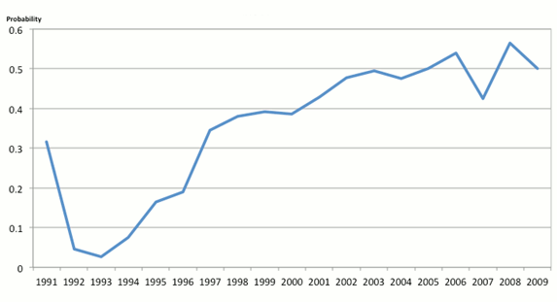
Figure 3 shows the same three-year-ahead out-of-sample probabilities of systemic banking crisis in emerging countries (for the entire emerging group and by region) from 1991 to 2008. Starting from elevated levels in the 1990s, we observe a sharp decline in the out-of-sample probabilities after the late 1990s. Overall, the probabilities remain low thereafter, especially in emerging Asia. We do find, however, a marked increase in banking-crisis risk in emerging Europe after 2002, and a more modest increase in Latin America, consistent with the growth performance in Figure 1. Our model does not predict Russia’s banking crisis, however.

Figure 3. Three-year-ahead out-of-sample probability of banking crisis in emerging economies
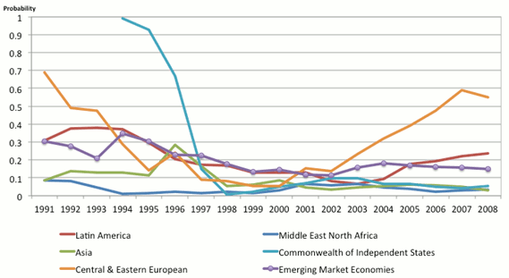

A recent concern for emerging markets has been a high level of capital inflows, facilitated by foreign-exchange intervention and associated with rapid domestic-credit growth and alleged asset-price bubbles. In light of our model’s ability to predict the 2007–09 banking crises in advanced economies, it may be informative to ask where the predicted crisis probabilities for emerging markets currently stand. Figure 4 provides an answer to this question. It reports a decomposition of the log-odds ratio for five-year-ahead probabilities of a banking crisis in emerging economies into its various empirical determinants, relative to 1973. The log-odds ratio is the solid black line, with corresponding values on the right vertical axis.⁷ The bars report, on the left axis, the contribution of each variable from our empirical model, expressed as a change from the 1973 value.⁸

Figure 4. Decomposition of the five-year-ahead log-odds ratio of banking crises in emerging economies
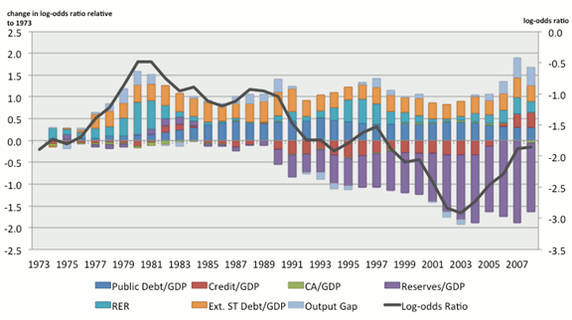
In the aftermath of the East Asian financial crisis, the probability of banking crises declined significantly as levels of domestic credit relative to GDP remained depressed, as central banks accumulated significant holdings of international reserves, and as economies avoided overheating. The figure indicates that emerging market economies are now moving back toward higher levels of risk. Despite still-elevated reserve stocks compared to historical standards, the danger now comes from potential overheating and incipient domestic-credit booms. While the overall probabilities of crisis remain small according to our model, the trend since 2003 could be a source of concern for policymakers, especially in Bulgaria, Venezuela, Sri Lanka, and Argentina, all countries with rapidly increasing probabilities of a banking crisis in the next five years (an increase in excess of ten percentage points in 2007 or 2008).

Conclusion
Simple probability models of the type we have estimated are unable to capture the full range of factors, some social and political, that can influence the likelihood that a crisis breaks out in the near or medium term. Nonetheless, we believe that big increases in the crisis probabilities implied by these models should prompt policymakers at least to ask tough questions about the health of countries’ economic and financial fundamentals, and the need for corrective action.

References
Bordo, Michael, Barry Eichengreen, Daniela Klingebiel and Soledad Martinez-Peria (2001), “Is the Crisis Problem Growing More Severe?” Economic Policy, 16 (April): 5–82.
Borio, Claudio and Philip Lowe (2002), “Assessing the Risk of Banking Crises”, BIS Quarterly Review (December): 43–54.
Borio, Claudio and William R. White (2004), “Whither Monetary and Financial Stability? The Implications of Evolving Policy Regimes”, in Monetary Policy and Uncertainty: Adapting to a Changing Economy. Kansas City, MO: Federal Reserve Bank of Kansas City.
Didier, Tatiana, Constantino Hevia, and Sergio Schmukler (2011), “How Resilient Were Emerging Economies to the Global Crisis?” Policy Research Working Paper 5637, World Bank, April.
O’Rourke and Eichengreen (2010), A tale of two depressions: What do the new data tell us? February 2010 update, VoxEU.org, 8 March.
Gourinchas, Pierre-Olivier and Maurice Obstfeld (2012), “Stories of the Twentieth Century for the Twenty-First”, American Economic Journal: Macroeconomics, 4 (January): 226–65.
Hume, Michael and Andrew Sentance (2009), “The Global Credit Boom: Challenges for Macroeconomics and Policy”, Journal of International Money and Finance, 28 (December): 1426–61.
Kose, M. Ayhan and Eswar S. Prasad (2010), Emerging Markets: Resilience and Growth amid Global Turmoil, Washington, DC: Brookings Institution Press.
Laeven, Luc and Fabian Valencia (2010), “Resolution of Banking Crises: The Good, the Bad, and the Ugly”, IMF Working Paper WP/10/146, June.
Prasad, Eswar S (2011), “Role Reversal in International Finance,” Federal Reserve Bank of Kansas City Jackson Hole Symposium, August.
Reinhart, Carmen M and Kenneth S Rogoff (2009), This Time is Different: Eight Centuries of Financial Folly, Princeton, NJ: Princeton University Press.
Schularick, Moritz and Alan M Taylor (forthcoming), “Credit Booms Gone Bust: Monetary Policy, Leverage Cycles and Financial Crises, 1870-2008”, American Economic Review 102.

¹ On the comparative resilience of the developing world in recent years, see Kose and Prasad (2010), Didier et al (2011), and Prasad (2011). Of course, not all emerging regions fared equally. On most measures, one observes the most severe downturns in Central and Eastern Europe and the Commonwealth of Independent States.
² We relied on earlier work by Bordo et al (2001), Reinhart and Rogoff (2009), Laeven and Valencia (2010), and others. Our approach distinguishes banking, currency, and default crises, the latter category defined to include internal as well as external default and restructuring events for public-sector debt.
3 A growing recent literature examines the correlation between economies’ initial characteristics and the severity of the output collapse during the recent crisis. There is insufficient room to survey that literature here, but see Gourinchas and Obstfeld (2012) for a summary.
⁴ On the BIS view, see Borio and Lowe (2002) and Borio and White (2004). See Hume and Sentance (2009) and Schularick and Taylor (forthcoming) for recent contributions that stress the role of leverage. In Gourinchas and Obstfeld (2012), we provide a selection of earlier references.
⁵ Borio and Lowe (2002) reached a similar conclusion regarding emerging markets. In the case of emerging markets, we added external short-term debt to the list of potentially informative variables.
⁶ The figure reports the average probability of systemic banking crisis, over the group of advanced countries. To construct the out-of-sample forecasts, we re-estimate our (panel logit) model every period starting in 1991, using only the sample of past and current data that would actually have been available to the forecaster. All forecasts are based in part on detrended data, but we are careful to use rolling trends based only on data available up to the time of the forecast. (We do not, however, account for retrospective data revisions by national statistical agencies.)
⁷ The log-odds ratio refers to the log of the ratio of the probability of crisis to the probability of no crisis. A log-odds ratio of zero means the crisis and no-crisis outcomes look equally likely.

⁸ Specifically, the sum of all the bars in a given year equals the change in the log-odds ratio between 1973 and that year.

Top of Form
Bottom of Form

