The value-added content of trade

Robert Johnson Guillermo Noguera
7 June 2011, VOX.EU

Roughly two-thirds of international trade is in intermediate goods. As a result, measures of trade flows that tally the gross value of goods at each border crossing lead to a distorted view of world trade. Using a value-added measure, this column finds that the controversial US-China imbalance is in fact around 40% smaller than many people think.

Trade in intermediate inputs accounts for roughly two-thirds of international trade. This input trade reflects the increasing fragmentation of production processes across borders.¹ It also creates two distinct challenges for measuring international interdependence.
- First, conventional gross trade statistics tally the gross value of goods at each border crossing, rather than the net value added between border crossings.
This well-known “double-counting” problem means that conventional data overstate the domestic value-added content of exports. Using input-output tables for individual G7 countries, existing estimates suggest that the import content of exports is 20%-30% and rising over time (Hummels et al. 2001, NRC 2006). Estimates for countries heavily engaged in processing trade (e.g. China) are on the order of 50% (Koopman et al. 2008).
- Second, multi-country production chains imply that intermediate goods can travel to their final destination by an indirect route.

For example, if Korean intermediates are assembled in China into final goods exported to the US, then Chinese bilateral gross exports embody Korean content. These chains make bilateral trade flows a misleading guide to the true origin or destination where content is produced or consumed.
Together, “double-counting” and multi-country production chains imply that there is a hidden structure of value-added trade underlying gross trade flows. Accurate measurement of this value-added trade is key to understanding how countries are linked to each other through the global production structure.² Motivated by these concerns, our recent work attacks the problem of extracting the value-added content of bilateral trade from existing data sources.

Tracking intermediates: A global bilateral input-output table
To compute the value-added content of trade, we require a global bilateral input-output table that describes how particular sectors in each destination country purchase intermediates from both home and individual foreign sources, as well as how each country sources final goods.

These flows are not typically recorded in trade and national accounts data. So we construct a synthetic table by combining input-output tables and bilateral trade data for many countries.³ In doing so, we make two proportionality assumptions.⁴
- First, within each sector, we assume that total imports from each source country are split between final and intermediate use in proportion to the average split of total imports between final and intermediate use in the destination country.
- Second, we assume intermediate imports from each source country are split across purchasing sectors in proportion to their overall imported intermediate use in the destination country.
Using the resulting global bilateral input-output table, we perform a calculation that allocates the gross output produced in each source country to the destination in which it is ultimately absorbed in final demand. We then use value added to output ratios from the source country to compute the value added associated with these implicit output transfers. The end result is a data set of “value-added exports” that describes the destination where the value added produced in each source country is absorbed.

Main findings
We focus our analysis on the ratio of value-added exports to gross exports, which we call the “VAX” ratio. For example, for US imports from Germany, the numerator is the sum of all value added in Germany that ends up in the US. Thus it includes the value added of Germany’s direct exports to the US plus all the “indirect” exports such as British exports to the US that contain German value added. The denominator is the standard bilateral trade flow, so the ratio can be above or below unity. Table 1 presents aggregate VAX ratios for selected countries and separate VAX ratios for manufacturing, services, and agriculture, and natural resources sector composites.⁵

Table 1. Aggregate and sectoral VAX ratios
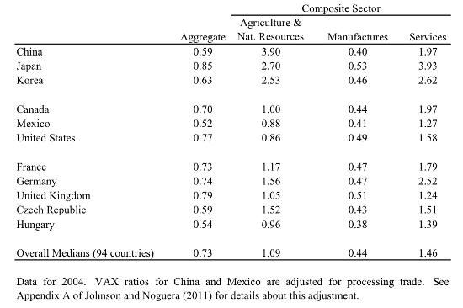
Across sectors, the VAX ratio is substantially lower in manufacturing than in other sectors. This is primarily due to the fact that the manufacturing sector purchases inputs from non-manufacturing sectors, and therefore exports of manufactured goods contain value added originating in those non-manufacturing sectors. Put differently, value added from the services sector is traded indirectly, embodied in physical manufactured goods that actually cross the border. This implies that services constitute a substantially larger share (and manufacturing constitutes a smaller share) of value-added trade than gross trade.

One implication of this cross-sector variation in VAX ratios is that the composition of trade shapes aggregate VAX ratios across countries. Specifically, countries that export manufactures have lower aggregate VAX ratios. Despite this fact, aggregate VAX ratios do not co-vary strongly with income per capita. While richer countries tend to export manufactures, which lowers their aggregate VAX ratios, they also export at higher VAX ratios within the manufacturing sector.

The bilateral VAX ratios also vary in informative ways across bilateral trading partners. To illustrate this variation, we present bilateral VAX ratios for the US in Figure 1. The US has relatively low VAX ratios for trade vis-à-vis its NAFTA and Emerging-Asia trade partners, as compared to much higher ratios with Japan and major Western European countries.

This bilateral variation is shaped by the underlying structure of production chains.⁶ As inputs travel back-and-forth (e.g., between the US and Mexico), this inflates gross trade flows and pushes down the VAX ratio. However, these ratios also reflect multilateral (“triangular”) production chains. For example, the VAX ratio for US imports from Australia exceeds 1, largely because Australia ships inputs to Asia, which are then embedded in final goods that end up in the US. Following a similar logic, the VAX ratio for US imports from Korea is around 20 percentage points higher than for US exports to Korea, due to Korea supplying intermediates to other countries (e.g., China) that process those inputs into final goods for consumption in the US.

This variation in VAX ratios across bilateral partners implies that bilateral trade imbalances can look different when measured in value added versus gross terms. Sticking with the US example, we present bilateral balances for selected Asian countries in Figure 2. Strikingly, the US-China imbalance is approximately 40% smaller when measured on a value added basis, while the US-Japan imbalance is approximately 33% higher. These adjustments point to the importance of triangular production chains within Asia, and generalise intuition derived from case studies of particular products (e.g. Apple’s iPod) produced by “factory Asia” (Xing 2011).

Figure 1. US bilateral trade with selected partners
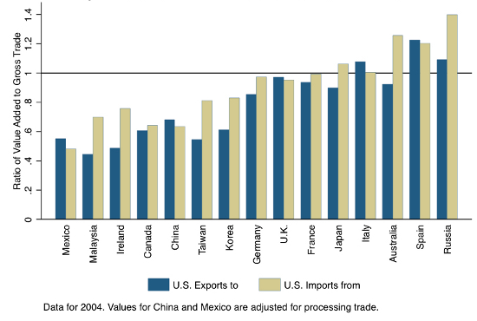
Figure 2. Bilateral trade and value added balances for the US, by partner
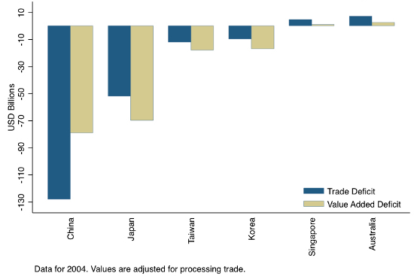

Applications and challenges
These data on the value-added content of trade (or the intermediate goods flows that underlie them) have many uses. They can be used to calibrate openness and bilateral exposure to foreign shocks in international business cycle research (Bems et al. 2010). For trade research, they can be used to calibrate gravity-style trade models to allow for differences in trade patterns for final and intermediate goods (Noguera 2011). They could also be employed to calibrate many-country models of multi-stage production and vertical specialisation, as in Yi (2010). And these applications only scratch the surface.
Going forward, we see two major research challenges. First, much work is needed to improve the quality of the data underlying the computation of value-added trade.⁷ Second, and arguably more importantly, some hard thinking is needed to understand the implications of this new view of trade. For some questions, we fully expect that measuring trade in value added and gross terms will imply similar conclusions. Pinpointing where this shift in perspective generates important differences in conceptual or quantitative answers to questions is the name of the game, and we are at work on this agenda.

References
Bems, Rudolfs, Robert C Johnson, and Kei-Mu Yi (2010), "Demand Spillovers and the Collapse of Trade in the Global Recession", IMF Economic Review, 58(2):295-326.
Daudin, Guillame, Christin Rifflart, and Schweisguth (forthcoming), "Who Produces for Whom in the World Economy?", Canadian Journal of Economics.
Hummels, David, Jun Ishii, and Kei-Mu Yi (2001), "The nature and growth of vertical specialization in world trade", Journal of International Economics, 54:75-96.
Johnson, Robert C. and Guillermo Noguera (2011). "Accounting for Intermediates: Production Sharing and Trade in Value Added", Unpublished Manuscript, Dartmouth College.
Koopman, Robert, Zhi Wang, and Shang-Jin Wei (2008). "How much of Chinese exports is really made in China?", VoxEU.org, 8 August.
Koopman, Robert, William Powers, Zhi Wang, Shang-Jin Wei (2010), "Give Credit Where Credit Is Due: Tracing Value Added in Global Production Chains", Unpublished Manuscript, US International Trade Commission.
Lamy, Pascal (2011). "`Made in China' tells us little about global trade", Financial Times, 24 January.
NRC (2006). "Analyzing the US Content of Imports and the Foreign Content of Exports", Washington DC, National Research Council, The National Academies Press.
Noguera, Guillermo (2011), "Augmented Gravity: Accounting for Production Sharing", Unpublished Manuscript, Columbia Business School.
Trefler, Daniel and Susan Zhu (2010), "The Structure of Factor Content Predictions", Journal of International Economics, 82:195-207.
Xing, Yuqing (2011), "How the iPhone widens the US trade deficit with China", VoxEU.org, 10 April.
Yi, Kei-Mu (2010). “Can Multistage Production Explain the Home Bias in Trade?” American Economic Review, vol. 100 (1), p. 364-393.

¹ This phenomenon is alternatively referred to as international production sharing, offshoring, vertical specialisation, or slicing up the value chain.
² Lamy (2011) goes so far as to suggest that these measurement problems underpin geopolitical frictions over trade imbalances, exchange-rate policy, and multilateral trade cooperation.
³ We take input-output tables and trade data from the GTAP 7.1 Database.
⁴ Proportionality assumptions are the standard approach to dealing with incomplete data in input-output accounting. In addition to our work, see Daudin et al. (forthcoming) and Trefler and Zhu (2010) for recent applications of proportionality to construct global input-output tables. An alternative approach would be to use UN Broad Economic Categories classification to separate final and intermediate goods in trade, as in Koopman et al. (2010). Using this approach instead of proportionality appears to yield small differences in aggregate value-added trade, though differences may be larger at the sector level.
⁵ Aggregating across sectors and export destinations for each source country, the VAX ratio can be interpreted as a metric of the domestic content of exports. However, this interpretation breaks down looking at individual sectors or bilateral country pairs. At the sector or bilateral level, VAX ratios shed light on the structure of production linkages. See Johnson and Noguera (2011) for details.
⁶ In our paper, we perform several decompositions to shed light on the link between VAX ratios and production chains. In the first decomposition, we show that most of the variation in bilateral value added to export ratios arises due to production sharing, not variation in the composition of goods exported to different destinations. The second decomposition splits bilateral exports according to whether they are absorbed in the destination, embedded as intermediates in goods that are reflected back to the source country, or redirected to third countries embedded as intermediates in goods ultimately consumed there. Variation in the degree of absorption, reflection, and redirection across partners is an important driver of variation in bilateral value added to export ratios.

⁷ We welcome on-going efforts to integrate bilateral final and intermediate goods shipments data into the national accounts architecture. See the program of The World Bank’s workshop on Fragmentation of Global Production and Trade in Value-Added for details on some of the data initiatives.

