The Eurozone crisis: Fiscal fragility, external imbalances, or both?
Pietro Alessandrini Michele Fratianni Andrew Hughes Hallett Andrea F Presbitero
16 May 2012

Unsustainable debt along Europe’s periphery is bringing the euro to breaking point. But this column argues that this is not simply the result of fiscal ill-discipline. After 2010, the Eurozone crisis went from a fiscal crisis to a balance-of-payments crisis – with different prescriptions for policy.

The speculative attack against Eurozone sovereign debt, reflected in the extraordinary rise in the yields of government bonds for Greece, Ireland, Italy, Portugal, and Spain (known affectionately as the GIIPS) since the start of 2010, has sparked a heated policy debate on how best to stabilise the Eurozone (see the Vox debate moderated by Corsetti 2012). Two main views have emerged:
- The ‘German’ view, which prescribes the necessity of fiscal austerity in the south of the Eurozone to lessen the risk that the south may be forced to abandon the euro.

This view represents now the prevailing regime and it is justified by the claim that southern countries have been fiscally irresponsible and have failed to implement supply-side policies (Von Hagen et al 2011).
- The Keynesian view, according to which the Eurozone sovereign debt crisis is viewed as being a balance-of-payments crisis, with the Eurozone north benefiting from surpluses and the Eurozone south suffering from deficits (Blanchard 2007; Merler and Pisani-Ferry 2012).

This interpretation argues that the current emphasis on fiscal austerity risks of being counter-productive, given its negative impact on expected long-term growth rates (DeLong and Summers 2012).

An interpretation of the Eurozone crisis
In a recent paper (Alessandrini et al 2012), we provide a general framework to demonstrate how poor fundamentals can create a debt problem – with or without fiscal irresponsibility. We also stress how these imbalances may cause a liquidity crisis with sudden stops, and assess the relative importance of fiscal fundamentals and external imbalances to explain yield spreads in the Eurozone. These stylised facts and the empirical evidence suggest that both the fiscal fragility of the south, and the north-south divide of external imbalances, contribute to the ongoing EZ crisis.

Stylised facts and empirical findings
A first set of stylised facts raises some doubt about the validity of the proposition that the Eurozone debt crisis is mainly driven by fiscal fragility in the south (Table 1).

- The comparison of government debt levels and primary government balances in the Eurozone south, and in the UK, US and Japan, suggest that yield spreads may be a symptom rather than a proximate cause of the malady and that fiscal fundamentals alone are not enough to explain sovereign risk (Dadush and Wyne 2012).
- Even within the Eurozone, some southern countries had sounder fiscal positions than Germany before the onset of the crisis (Krugman 2012)¹.
A second set of stylised facts:
- The north has benefited from lower unit labour cost growth and a real exchange-rate depreciation relative to the south (Table 2).

Table 1. Government gross debt to GDP in the Eurozone, UK, US, and Japan,1999-2011
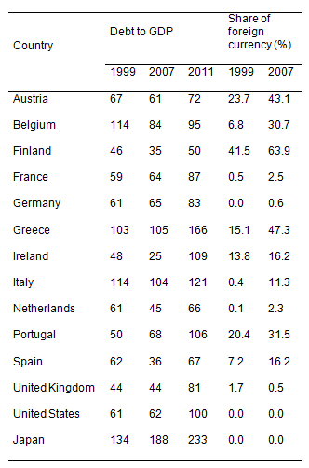
Source: International Monetary Fund, World Economic Outlook Database, September 2011, and Panizza and Presbitero (2012).
Table 2. Current-account balances, unit labour costs and inflation rates, 11 Eurozone countries, 1999-2012
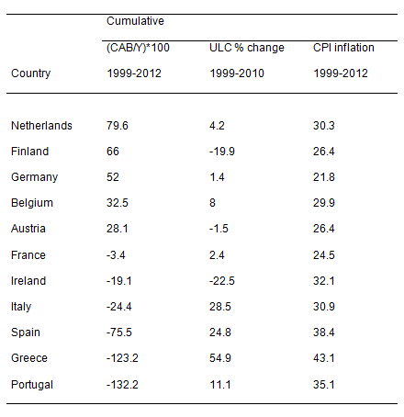
Notes: CAB = current-account balance, Y = GDP, ULC = unit labour cost, CPI = Consumer Price Index, 2012 values are forecast. Source: International Monetary Fund, World Economic Outlook Database, September 2011 for CAB, Y and CPI inflation; OECD, Main Economic Indicators for ULC.

These data are consistent with the hypothesis that the asymmetry in the Eurozone external imbalances is driven by, among other factors, wage and labour productivity differentials which have not been compensated by real exchange rate adjustments.
- Besides, large foreign bank lending from the north to the south before the crisis, sudden capital reversals in the wake of the crisis, and mounting Target2 imbalances support the balance-of-payments interpretation of the Eurozone crisis (Buiter et al 2011).

Our empirical estimates of the determinants of government bond yield spreads relative to Germany point to the greater importance of market liquidity in times of uncertainty, and suggest a shift from a fiscal to a balance-of-payments crisis driven by labour productivity differentials between north and south.

Our estimates show that differences in liquidity and public debt with respect to Germany are the two main determinants of yield spreads, accounting for 86 and 46 basis points respectively out of an average 290 basis points increase in Eurozone spreads in the period from 2008Q3 to 2011Q2. But if we focus exclusively on the sovereign debt crisis period (2010Q1-2011Q2) instead, the role of public debt becomes negligible, while differences in labour productivity emerge as the ‘other major factor’, together with market liquidity, in explaining the widening yield spreads².

Conclusions
The fiscal imbalances of southern countries have certainly contributed to exacerbate the Eurozone fragility, but the latter cannot be interpreted only as the result of fiscal indiscipline. The present regime of fiscal austerity may therefore be correcting a symptom rather than the fundamental cause of the Eurozone crisis.

This alternative interpretation of the Eurozone fragility being driven by a balance-of-payments crisis is not necessarily inconsistent with the fiscal interpretation. This view recognises the importance of the long-run fiscal adjustment, but identifies the source of the sovereign crisis in an inadequate adjustment (and an inappropriate adjustment burden sharing) between surplus and deficit countries in the monetary union.

The Eurozone is structurally fragile. While speculative attacks may reflect genuine concerns about debt sustainability in the south, the deep divide between the external surplus of the north and the deficit of the south cannot be dismissed as a potential trigger mechanism of the debt crisis and its stubborn resistance to fiscal therapy.
Stubborn resistance may well reflect the absence of a transfer mechanism that would normally be present in sovereign states, non-equilibrating real exchange-rate movements, and low economic growth. These are old problems going back to the MacDougall and Delors reports, and their call for a sizable centralised fiscal budget in the Eurozone to stabilise transitory regional shocks by redistributing resources among regions.

References
Alessandrini, P, M Fratianni, A Hughes Hallett, and A Presbitero (2012), “External imbalances and financial fragility in the Eurozone”, MoFiR working paper No. 66.
Blanchard, O (2007), "Adjustment within the euro. The difficult case of Portugal", Portuguese Economic Journal, 6.
Buiter, W, E Rahbari, and J Michels (2011), “The implications of intra-Eurozone imbalances in credit flows”, CEPR Policy Insight, No. 57.
Corsetti, G (2012), “Has austerity gone too far?”, VoxEU.org, 2 April.
Dadush, U and Z Wyne (2012), “Is the euro rescue succeeding? An update”, VoxEU.org, 20 April.
DeLong, B and L Summers (2012), “Fiscal policy in a depressed economy”, paper presented at the Spring 2012 Brookings Panel.
Goodhart, C E and D Schoenmaker (2012), “The political endgame for the euro crisis”, VoxEU.org, 14 December.
Krugman, P (2012), “Insane in Spain”, The New York Times, 15 April.
Merler, S and J Pisani-Ferry (2012), “Sudden stops in the Eurozone”, VoxEU.org, 2 April.
Panizza, U and A Presbitero (2012), “Public debt and economic growth: Is there a causal effect?”, MoFiR working paper, No. 65.
Von Hagen, J, L Schuknecht and G Wolswijk (2011), “Government bond risk premiums in the EU revised: The impact of the financial crisis”, European Journal of Political Economy, 27:36-43.

1The fiscal fragility of the south may emerge from the higher share of government debt denominated in foreign currencies. By contrast, the UK, the US, Japan and Germany had virtually all government debt denominated in local currency, reducing the exposition to valuation effects due to exchange rate fluctuations.
2For more details on the estimated model and the computation of the relative contributions of the model’s factors, see section 5 of our paper (Alessandrini et al 2012). See also Goodhart and Schoenmaker (2011) on this site.

Top of Form
Bottom of Form

